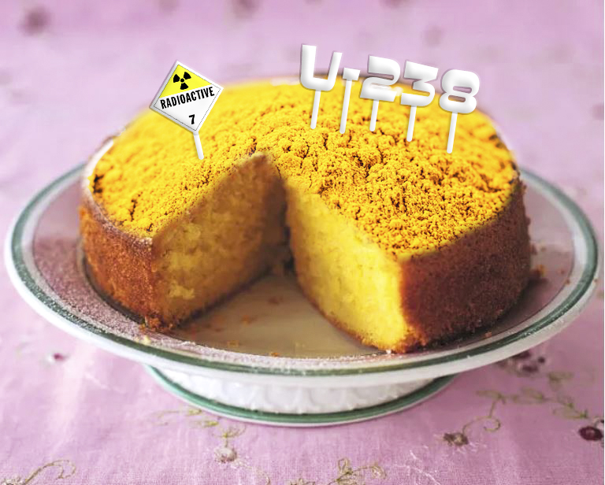

Don’t Eat That Cake
After Action Report / Improvement Plan
Southern Region Health Care Coalition
February 13, 2023

Exercise Overview
Exercise Name | Don’t Eat That Cake
Exercise Dates | February 13, 2023
Scope | This is a tabletop exercise, planned for three hours via a virtual platform. Exercise play is limited to registered entities.
Focus Area(s) | Response
Capabilities | - Environmental Response/Health and Safety  - Operational Coordination  - Public Health, Healthcare, and Emergency Medical Services
Objectives | - Participating entities will identify the threat or hazard accurately and in a timely manner.  - Necessary resources will be identified and activated appropriately and in a timely manner.  - Hazard control, victim and responder safety measures, and appropriate Personal Protective Equipment will be immediately implemented and maintained throughout the incident.  - Patients will be appropriately triaged and treated.
Threat or Hazard | Accidental radiological release.
Scenario | While inventorying the contents of abandoned storage units, multiple people are contaminated with yellow cake uranium and exposed to Cs-137.
Sponsor | Southern Region Health Care Coalition
Participating Jurisdictions/ Organizations | - Billings Clinic  - Livingston Healthcare  - Montana Department of Health and Human Services  - Pioneer Medical Center  - Southern Region Health Care Coalition  - Wheatland Memorial Healthcare
Point of Contact | Jason Mahoney  Owner / Consultant  373 Consulting LLC  406-670-3548  Jason@373consulting.com  www.373consulting.com

Analysis of Capabilities
Aligning exercise objectives and capabilities provides a consistent taxonomy for evaluation that transcends individual exercises to support preparedness reporting and trend analysis. Table 1 includes the exercise objectives, aligned capabilities, and performance ratings for each capability as observed during the exercise and determined by the evaluation team.
Objective | Capability | Performed without Challenges (P) | Performed with Some Challenges (S) | Performed with Major Challenges (M) | Unable to be Performed (U)
1. Participating entities will identify the threat or hazard accurately and in a timely manner. | - Environmental Response/Health and Safety  - Operational Coordination |  | X
2. Necessary resources will be identified and activated appropriately and in a timely manner. | - Environmental Response/Health and Safety  - Operational Coordination  - Public Health, Healthcare, and Emergency Medical Services |  | X
3. Hazard control, victim and responder safety measures, and appropriate Personal Protective Equipment will be immediately implemented and maintained throughout the incident. | - Environmental Response/Health and Safety  - Operational Coordination  - Public Health, Healthcare, and Emergency Medical Services |  |  | X
4. Patients will be appropriately triaged and treated. | - Public Health, Healthcare, and Emergency Medical Services |  | X

Table 1. Summary of Core Capability Performance
Ratings Definitions:
Performed without Challenges (P): The targets and critical tasks associated with the capability were completed in a manner that achieved the objective(s) and did not negatively impact the performance of other activities. Performance of this activity did not contribute to additional health and/or safety risks for the public or for emergency workers, and it was conducted in accordance with applicable plans, policies, procedures, regulations, and laws.
Performed with Some Challenges (S): The targets and critical tasks associated with the capability were completed in a manner that achieved the objective(s) and did not negatively impact the performance of other activities. Performance of this activity did not contribute to additional health and/or safety risks for the public or for emergency workers, and it was conducted in accordance with applicable plans, policies, procedures, regulations, and laws. However, opportunities to enhance effectiveness and/or efficiency were identified.
Performed with Major Challenges (M): The targets and critical tasks associated with the capability were completed in a manner that achieved the objective(s), but some or all of the following were observed: demonstrated performance had a negative impact on the performance of other activities; contributed to additional health and/or safety risks for the public or for emergency workers; and/or was not conducted in accordance with applicable plans, policies, procedures, regulations, and laws.
Unable to be Performed (U): The targets and critical tasks associated with the capability were not performed in a manner that achieved the objective(s).
The following sections provide an overview of the performance related to each exercise objective and associated capability, highlighting strengths and areas for improvement.

Objective 1

Participating entities will identify the threat or hazard accurately and in a timely manner.

Capability 1

Environmental Response/Health and Safety

Strengths
The partial capability level can be attributed to the following strengths:
Strength 1: Some participants had worked to provide access to online resources like the Wireless Information System for Emergency Responders (WISER).

Areas for Improvement
The following areas require improvement to achieve the full capability level:
Area for Improvement 1: One facility’s link to WISER would not work, and all participants were unaware that WISER will be decommissioned on 02/28/2023. Additional resources are available to provide much more in-depth information, but participating entities were not familiar with them.
Reference: N/A
Analysis: Immediate access to up-to-date information is critical during hazmat response, and response entities need to ensure they have multiple platforms as sources for this information.

Capability 2

Operational Coordination

Strengths
The partial capability level can be attributed to the following strengths:
Strength 1: Participants were able to verbalize notification of state-level entities that would assist in identification and information gathering around the identified threat.

Areas for Improvement
The following areas require improvement to achieve the full capability level:
Area for Improvement 1: Generally, participants were unclear on the processes around coordinating with the 83rd Civil Support Team (CST) including notification/activation, team capabilities and limitations, consultation versus full response, etc.
Reference: N/A
Analysis: The 83rd CST is an outstanding resource during hazmat incidents, but without knowledge certain processes/procedures they could be underutilized or expected to work outside their role.

Objective 2

Necessary resources will be identified and activated appropriately and in a timely manner.

Capability 1

Environmental Response/Health and Safety

Strengths
The partial capability level can be attributed to the following strengths:
Strength 1: Initial response to the scene was appropriate and timely.
Strength 2: ICS/HICS activation was considered early on.

Areas for Improvement
The following areas require improvement to achieve the full capability level:
Area for Improvement 1: Healthcare entities did not notify the Department of Health and Human Services (DPHHS) Duty Officer nor the Coalition Coordinator.
Reference: N/A
Analysis: It seems that the healthcare entities may not be aware of the need and/or the benefits of early notification of these entities, and there may be a sense that “there’s no time to make more phone calls” during the response phase of an incident.

Capability 2

Operational Coordination

Strengths
The partial capability level can be attributed to the following strengths:
Strength 1: Initial response to the scene was appropriate and timely.
Strength 2: ICS/HICS activation was considered early on.

Areas for Improvement
The following areas require improvement to achieve the full capability level:
Area for Improvement 1: Healthcare entities did not notify the Department of Health and Human Services (DPHHS) Duty Officer nor the Coalition Coordinator.
Reference: N/A
Analysis: It seems that the healthcare entities may not be aware of the need and/or the benefits of early notification of these entities, and there may be a sense that “there’s no time to make more phone calls” during the response phase of an incident.

Capability 3

Public Health, Healthcare, and Emergency Medical Services

Strengths
The partial capability level can be attributed to the following strengths:
Strength 1: Initial response to the scene was appropriate and timely.
Strength 2: ICS/HICS activation was considered early on.

Areas for Improvement
The following areas require improvement to achieve the full capability level:
Area for Improvement 1: Until they were prompted, none of the participants considered locating survey equipment (Geiger Counters, Ludlum Meters, etc.) to assist in initial screening of possibly contaminated patients.
Reference: N/A
Analysis: Some larger facilities have radiologic survey equipment, but many smaller facilities do not. Since this equipment can streamline assessment and decontamination processes, it should be ordered as soon as possible.

Objective 3

Hazard control, victim and responder safety measures, and appropriate Personal Protective Equipment will be immediately implemented and maintained throughout the incident.

Capability 1

Environmental Response/Health and Safety

Strengths
The partial capability level can be attributed to the following strengths:
Strength 1: Most participants have decontamination equipment, PPE, and supplies available.
Strength 2: A number of hospitals have fixed facility decontamination facilities and Level C PPE and one has both fixed facility decontamination capability as well as a mobile decontamination trailer.
Strength 3: A number of entities have implemented access control measures which may have limited the movement of contaminated individuals and minimized contamination of the interior of the facility.
Strength 4: One hospital has equipped all of their Emergency Department rooms with negative airflow capability.

Areas for Improvement
The following areas require improvement to achieve the full capability level:
Area for Improvement 1: None of the participating entities has up-to-date training for staff that would be working the decontamination area.
Reference: N/A
Analysis: Hazmat and decontamination training is difficult to find, and the associated expense of initial training along with annual refreshers can be cost prohibitive for many facilities.
Area for Improvement 2: Few of the participating entities have a plan, MOU, etc. for disposal of contaminated waste following a hazmat response.
Reference: N/A
Analysis: Thankfully, hazmat incidents are relatively rare, but lack of a plan for hazardous waste disposal could open entities to increased risk if there are delays in appropriate waste removal.
Area for Improvement 3: Many participants were unsure of the PPE necessary to safely respond to a radiologic incident.
Reference: N/A
Analysis: There are numerous considerations to account for when choosing the correct PPE, and simple resources can make PPE decisions somewhat easier.
Area for Improvement 4: Participants with fixed facility decontamination capabilities were unsure of the capacity of their holding tanks and they did not have estimates of how many patients could be decontaminated before the tanks were full.
Reference: N/A
Analysis: Fixed facility decontamination facilities are a valuable resource, especially considering Montana’s weather challenges much of the year. However, facilities need to fully understand the extent of their capabilities in order to respond appropriately to an incident requiring decontamination of multiple patients.

Capability 2

Operational Coordination

Strengths
The partial capability level can be attributed to the following strengths:
Strength 1: Participants have remote access to informational resources through their hospital systems and/or through contracted services like Avera.
Strength 2: Billings Clinic has Medical Physicists that could function as subject matter experts if Billings Clinic was requested to provide information to an outlying facility.

Capability 3

Public Health, Healthcare, and Emergency Medical Services

Strengths
The partial capability level can be attributed to the following strengths:
Strength 1: Participants had strong ideas about how and when decontamination would be implemented.
Strength 2: Multiple participants referenced plans to limit the number of staff providing decontamination to patients in order to limit the possible impact of radiologic exposure to their overall response capability and individual staff members.

Areas for Improvement
The following areas require improvement to achieve the full capability level:
Area for Improvement 1: Some entities plan to use Emergency Department (ED) staff to decontaminate incoming patients.
Reference: N/A
Analysis: Most healthcare facilities are experiencing unprecedented staffing shortages, and rural facilities typically have a small number of staff tasked with numerous responsibilities. However, pulling ED staff into the decontamination area will likely create a drastic decrease in the facility’s ability to provide emergent patient care during a surge of contaminated patients.

Objective 4

Patients will be appropriately triaged and treated.

Capability 1

Public Health, Healthcare, and Emergency Medical Services

Strengths
The partial capability level can be attributed to the following strengths:
Strength 1: Most participants verbalized a well delineated plan on who performs patient triage.
Strength 2: Hospitals and EMS had pathways to obtain treatment information when encountering unusual situations like this hazmat incident.

Areas for Improvement
The following areas require improvement to achieve the full capability level:
Area for Improvement 1: While healthcare providers identified multiple “phone a friend” sort of resources for assessment and treatment information during a hazmat incident, those “friends” were, in a number of situations, not subject matter experts who would be able to provide timely and accurate assistance.
Reference: N/A
Analysis: The particular contaminants involved in the scenario are relatively rare, and most normal informational pathways would likely not be able to provide the specific information needed in a timely manner.

- Improvement Plan
Capability | Issue/Area for Improvement | Corrective Action | Primary Responsible Organization | Organization POC | Start Date | Completion Date | Notes
Capability 1: Environmental Response/Health and Safety | Participants were not aware of numerous hazmat informational resources that will be increasingly necessary when WISER sunsets. | Create a list, with links where available, of additional hazmat-specific resources and distribute to coalition members through the Coalition Coordinator. | 373 Consulting, SRHCC | Jason Mahoney, Jude Waerig | 02/13/2023 | 4/6/2023 | Added links and references to SRHCC Radiation anex
 | Most if not all participants do not have up to date training for staff that would be working the decontamination area. | Provide hospitals with hazmat/decon training to ensure decontamination is safe and effective for all involved. | SRHCC | Jude Waerig | 02/13/2023 | 12/2023 | HERT will be provided by end of calendar year 2023
 | Many participants were unsure of the PPE necessary to safely respond to a radiologic incident. | Provide coalition members with information on how to choose appropriate PPE. | 373 Consulting, SRHCC | Jason Mahoney, Jude Waerig | 02/13/2023 | 12/2023 | HERT training will be provided.
 | Participants with fixed facility decontamination capabilities were unsure of the capacity of their holding tanks and they did not have estimates of how many patients could be decontaminated before the tanks were full. | Determine holding tank capacities and consider running tests to determine the average number of patients that can be decontaminated before the tanks are full. | Hospitals with fixed facility decontamination capabilities | Per hospital | 02/13/2023 | Ongoing | Discuss with partners the need to include facilities and building maintenance in discussion and drill.
 | Few of the participating entities have a plan, MOU, etc. for disposal of contaminated waste following a hazmat response. | Develop a list of hazardous waste management companies and share it with coalition members through the Coalition Coordinator. | 373 Consulting, SRHCC | Jason Mahoney, Jude Waerig | 02/13/2023 | 12/2023 | Will include technical waste management organizations to be included in Annex
Capability 2: Operational Coordination | Generally, participants were unclear on the processes around coordinating with the 83rd Civil Support Team (CST) including notification/activation, team capabilities and limitations, consultation versus full response, etc. | Contact the 83rd CST and gather the information necessary to ensure that they are appropriately utilized in a timely manner. | 373 Consulting, SRHCC | Jason Mahoney, Jude Waerig | 02/13/2023 | 12/2023 | Ensure facilities and HC entities have the most updated contact and resources lists.
 |  | Consider having representatives of the 83rd CST present to coalition members during the upcoming Regional Meetings | 373 Consulting, SRHCC | Jason Mahoney, Jude Waerig | 02/13/2023 | 12/2023 | Determine appropriate timing and location for training
 | Healthcare entities did not notify the DPHHS Duty Officer nor the Coalition Coordinator. | Ensure that healthcare entities understand the necessity and benefits of these notifications, and ideally list these notifications in their plans. | SRHCC members | Jude Waerig | 02/13/2023 | 12/2023 | Work with HC facilities to ensure notification lists and expectations are up to date
Capability 3: Public Health, Healthcare, and Emergency Medical Services | Until they were prompted, none of the participants considered locating survey equipment (Geiger Counters, Ludlum Meters, etc.) to assist in initial screening of possibly contaminated patients. | Ensure that response entities are aware of sourcing for radiologic survey equipment and any processes to request it if they do not have their own. | SRHCC members | Jude Waerig | 02/13/2023 | 12/2023 | Determine distribution of equipment in region and state. Asses need for acquiring additional equipment.
 | Healthcare providers may not have been able to source timely assessment and treatment information for this hazmat incident. | Ensure that healthcare entities have resources to provide hazmat-specific information in a timely manner. This could include online resources, Poison Control and others being written into plans. | Healthcare entities | Per entity | 02/13/2023 | 4/6/2023 | Added links and references to SRHCC Radiation annex

Appendix B: Exercise Participants
Participating Organizations
State
Montana Department of Health and Human Services
Regional
Southern Region Health Care Coalition
Local
Billings Clinic
Livingston Healthcare
Pioneer Medical Center
Wheatland Memorial Healthcare
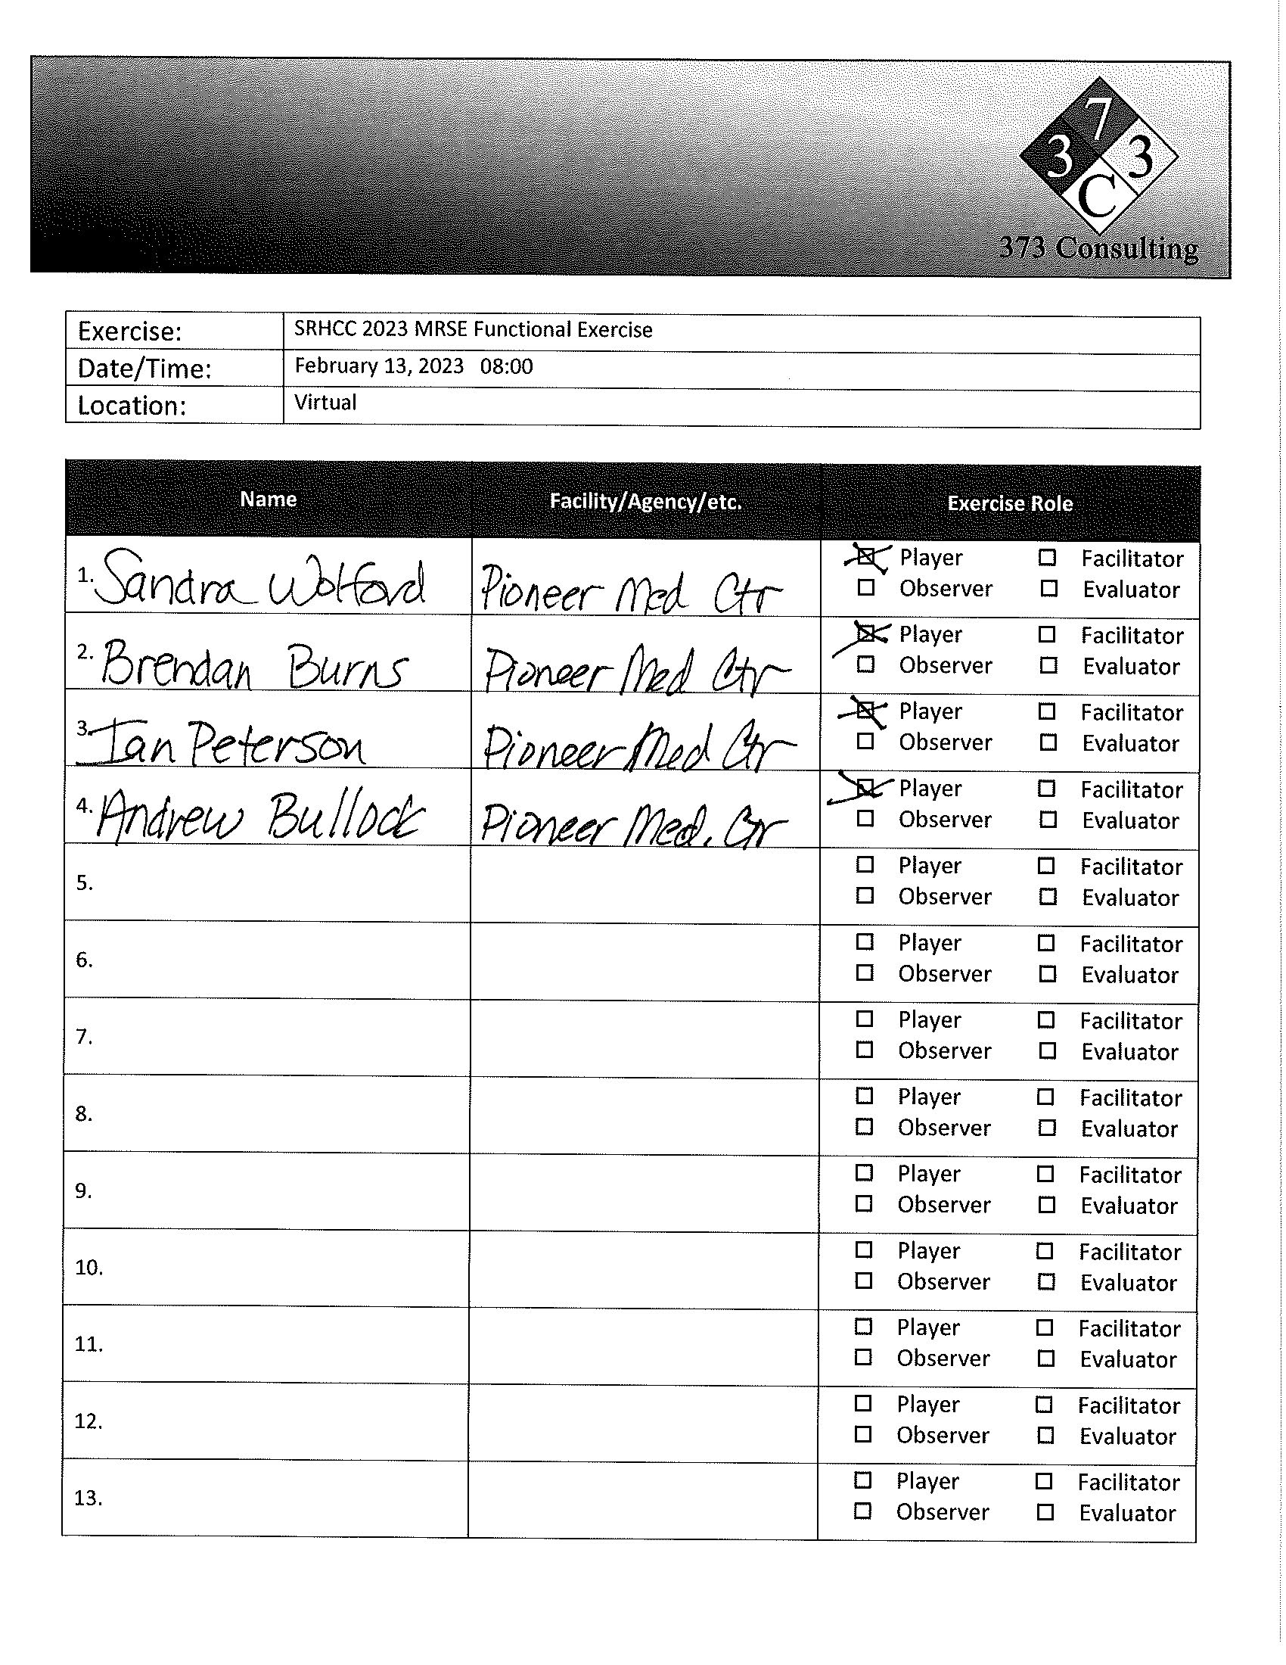

Appendix C: Exercise Questions

Appendix D: Participant Feedback Forms
