SRHCC 2023 MRSE Functional Exercise

After Action Report and Improvement Plan (AAR-IP)

Exercise Overview
Exercise Name | SRHCC 2023 MRSE Functional Exercise
Exercise Date | February 22, 2023
Scope | SRHCC 2023 MRSE is a Functional exercise, planned for 4 hours virtually via the MS Teams platform. The exercise emphasizes the role of the regional health care coalitions in supporting local hospitals and agencies responding to an emergency.
Mission Area(s) | Response, Recovery
Core Capabilities | Healthcare & Medical Response Coordination, (C2)  Continuity of Healthcare Service Delivery, (C3)  Medical Surge, (C4)
Objectives | Objective 1: Coordinate Response Strategy, Resources, and Communications (C2).  Objective 2: Plan for and Coordinate Health Care Evacuation and Relocation (C3).  Objective 3: Plan for a Medical Surge (C4).  Objective 4: Respond to a Medical Surge (C4)
Threat/Hazard | Medical Surge created by a hospital evacuation from a disaster area.
Scenario | A disaster impacted hospital must evacuate all of its patients immediately. There is no estimated repatriation date at this time so receiving facilities need to be prepared to keep the patients for several weeks, perhaps permanently through their recovery or treatment.
Sponsor(s) | Montana Regional Healthcare Coalitions, MTDPHHS, Montana Hospital Association (MHA)
Organization | Southern Region Health Care Coalition (SRHCC)
Point of Contact: | Jason Mahoney  Owner / Consultant  373 Consulting LLC  406-670-3548  Jason@373consulting.com

Analysis of Capabilities
Assessing response operations in the context of core capabilities provides a standard for evaluation to support reporting and trend analysis. Table 1 includes the core capabilities that defined local operations and performance ratings for each as assessed by the evaluation team.
Objective | Capability(s) | Performance Rating
- Coordinate Response Strategy, Resources, and Communications (C2). | Healthcare & Medical Response Coordination | 2 - Performed with Some Challenges
- Plan for and Coordinate Health Care Evacuation and Relocation (C3). | Continuity of Healthcare Service Delivery | 2 - Performed with Some Challenges
- Plan for a Medical Surge (C4). | Medical Surge | 2 - Performed with Some Challenges
- Respond to a Medical Surge (C4). | Medical Surge | 2 - Performed with Some Challenges
Ratings Definitions:
3 - Performed without Challenges: The targets and critical tasks associated with the core capability were completed in a manner that achieved the objective(s) and did not negatively impact the performance of other activities. Performance of this activity did not contribute to additional health and/or safety risks for the public or for emergency workers, and it was conducted in accordance with applicable plans, policies, procedures, regulations, and laws.
2 – Performed with Some Challenges: The targets and critical tasks associated with the core capability were completed in a manner that achieved the objective(s) and did not negatively impact the performance of other activities. Performance of this activity did not contribute to additional health and/or safety risks for the public or for emergency workers, and it was conducted in accordance with applicable plans, policies, procedures, regulations, and laws. However, opportunities to enhance effectiveness and/or efficiency were identified.
1 – Performed with Major Challenges: The targets and critical tasks associated with the core capability were completed in a manner that achieved the objective(s), but some or all of the following were observed: demonstrated performance had a negative impact on the performance of other activities; contributed to additional health and/or safety risks for the public or for emergency workers; and/or was not conducted in accordance with applicable plans, policies, procedures, regulations, and laws.
0 - Unable to be Performed: The targets and critical tasks associated with the core capability were not performed in a manner that achieved the objective(s).

Table 1. Summary of Core Capability Performance
The following sections provide an overview of the performance related to each core capability, highlighting strengths and areas for improvement.

Objective 1: Operational Coordination
Intent: To assess and validate the ability of coalition partners to coordinate together as part of a regional level response team.
Stated Objective: Coordinate Response Strategy, Resources, and Communications (C2).
Core Capability 1.1: Healthcare & Medical Response Coordination

Strengths
The following strengths related to this objective were observed during the exercise:
Strength 1: The Yellowstone County Unified Health Command (UHC) stood up to manage patient movement into the Billings area.
Strength 2: The Microsoft Teams platform provided multiple means of real-time communication for the group.
Strength 3: Viable organizational options including formation of an Incident Complex or Area Command were presented and considered.

Areas for Improvement
The following areas for improvement may help to achieve an even greater capability level:
Area for Improvement 1: Lack of Clear Command Structure
Analysis: The Yellowstone County UHC stood up and provided some organizational structure for those involved entities, but entities outside the Billings area were not equally supported through an organizational structure, so their input and resources were not fully leveraged.
Recommendations/Corrective Actions:
- Consider building command capability within the coalition leadership.
- Consider leveraging existing structures, like the Yellowstone County UHC, to include all impacted entities.
Area for Improvement 2: Notification and Communication
Analysis: There seemed to be significant confusion as to how notifications and other communication could be managed during an incident or disaster. Brett Lloyd had to remind participants that the Health Alert Network (HAN) system is available to all facilities and is a powerful tool for all sorts of communication.
Recommendations/Corrective Actions:
- Continue to promote the new HAN system and ensure that all possible entities are trained to use the system efficiently.

Objective 2: Relocation Planning
Intent: To assess the ability of participants to assess patients and identify needed resource support for their relocation after evacuation of their hospital during a disaster.
Stated Objective: Plan for and Coordinate Health Care Evacuation and Relocation (C3).
Core Capability 2.1: Continuity of Healthcare Service Delivery

Strengths
The following strengths related to this objective were observed during the Incident:
Strength 4: The Coalition Coordinator was contacted with a request for up-to-date available bed data from EM Resource which provided initial data on bed availability around the state.
Strength 5: The shared patient tracking spreadsheet with real-time updates visible by all participants was a valuable tool to attain and maintain a common operating picture throughout the planning process.
Strength 6: Participants embraced the exercise as a Functional Exercise and actually sent emails and made phone calls which illustrated availability of appropriate contact information during the planning phase.

Areas for Improvement
The following areas for improvement may help to achieve an even greater capability level:
Area for Improvement 4: National Guard Activation
Analysis: Few if any participants seemed to understand the process for activation of the National Guard, and there seemed to be significant overestimation of both their speed in mobilization and their capabilities once activated. On more than one occasion, participants requested to directly contact the Governor to request National Guard Activation.
Recommendations/Corrective Actions:
- Ensure that response entities have knowledge of procedures to request National Guard activation as well as realistic expectations of National Guard response times and capabilities.
Area for Improvement 5: Veterans Affairs Involvement
Analysis: Regionally, Veterans Affairs (VA) facilities have significant ESF8 capabilities, but they are not involved in the HCC’s. If they are allowed to participate in the HCC’s and provide assistance, resources, etc. during incidents or disasters, the HCC’s need to push for their participation in order to expand the pool of resources.
Recommendations/Corrective Actions:
- Research the possibility of VA facilities participating in the HCC’s.
- If VA facilities are allowed to participate, engage them and work towards adding them to HCC membership.
Area for Improvement 6: Understanding Capabilities and Limitations
Analysis: Pioneer Medical Center pointed out that, while they have staffed bed availability, they do not have an in-house Pharmacy so the patients they can accept cannot have pharmaceutical needs. This situation highlighted the fact that the HCC’s and their members probably do not have full awareness of both the capabilities and the limitations of partner entities.

Recommendations/Corrective Actions:
- If there is capacity, the HCC’s could develop or locate a list of critical healthcare functions and query member healthcare facilities to build a basic list of capabilities and limitations for use in planning or response activities. This may be available in EM Resource already, or it may be possible to add to that platform.
- If HCC capacity does not allow for development of a capabilities and limitations list, consider developing or locating a list of critical healthcare capabilities and limitations and use it as a just-in-time query when necessary during incident or disaster response. This approach may also possibly be available through EM Resource.

Objective 3: Surge Planning
Intent: To assess the ability of participants to develop strategies for joint decision making and information sharing to make proactive decisions about resource utilization.
Stated Objective: Plan for a Medical Surge (C4).
Core Capability 3.1: Medical Surge

Strengths
The following strengths related to this objective were observed during the Incident:
Strength 7: One entity thought outside the box and offered the possibility of borrowing transport vans from long term care facilities to provide wheelchair-capable transport as well as busses from Stillwater Mine for mass transport of more stable patients.
Strength 8: RiverStone Health in Billings is looking to expand their disaster response capabilities by sharing both nurse and provider staffing to Billings hospitals. They should also be able to provide Urgent Care or Emergency Department services in their clinic, and they may be able to offer surge capacity using open beds in their twelve-bed hospice house.
Strength 9: The Montana Primary Care Association has the ability to contact all of Montana’s Federally Qualified Health Centers (FQHC) and Indian Health Centers to assess for needs, capabilities, etc. during incidents or disasters.
Strength 10: Each HCC Coordinator has a contact list for all provider types in their coalition.

Areas for Improvement
The following areas for improvement may help to achieve an even greater capability level:
Area for Improvement 7: DES and ESF8 Integration
Analysis: When Montana Disaster and Emergency Services (DES) was contacted by Yellowstone County DES, the state representatives had no process or procedure to mobilize medical-specific resources through the HCC’s or other medical entities.
Recommendations/Corrective Actions:
- The HCC’s, along with the Healthcare Preparedness Program (HPP) and the Public Health Emergency Preparedness (PHEP) Program need to coordinate much more closely with DES and develop shared plans, procedures, etc. to promote rapid, cooperative response to incidents or disasters and efficient, timely mobilization of local, regional, and state resources.
Area for Improvement 8: ESF8 Partner Engagement
Analysis: Hospitals and Emergency Medical Service (EMS) agencies have been relatively engaged in the HCC’s since their inception. Other ESF8 partners, on the other hand, have been poorly represented. Entities like Public Health, Long Term Care, and Federally Qualified Health Centers (FQHC) have many talented people and a wealth of resources that have not been fully embraced or leveraged in planning or response. In some cases, it has been the fault of certain entities that do not respond to invitations to participate, but even during this exercise we saw hospitals, EMS and DES work closely together while other partners remained on the periphery despite their attempts to engage.
Recommendations/Corrective Actions:
- Work with all ESF8 partners to understand each entity’s capabilities.
- Brainstorm ways that partners’ capabilities may be utilized during incidents or disasters – even if these entities need to work outside their day-to-day roles.
- Add specific roles, responsibilities, etc. to HCC plans to ensure that valuable partners do not remain disengaged during incidents or disasters.
Area for Improvement 9: HCC Contact Lists
Analysis: During exercise play, there were numerous questions about how participants can contact healthcare entities throughout the state. Casey Driscoll stated that all HCC Coordinators have contact lists for all provider types across the state, but none of the participants requested contact information from those lists.
Recommendations/Corrective Actions:
- Ensure that coalition members are aware of all of the resources available to them through the HCC Coordinators – including contact lists for all provider types.

Objective 4: Surge Response
Intent: To assess the ability of participants to implement strategies to ensure stewardship of medical resources to provide the best possible care during a surge event.
Stated Objective: Respond to a Medical Surge (C4)
Core Capability 3.1: Medical Surge

Strengths
The following strengths related to this objective were observed during the Incident:
Strength 10: St. Vincent Healthcare considered pausing elective surgeries to free up more surge space during this incident.
Strength 11: Both Billings Clinic and St. Vincent Healthcare were able to leverage the strength of their healthcare systems to quickly identify capacity and capabilities outside the SRHCC.
Strength 12: Billings Clinic thought outside the box and contacted Edwards Jet Center directly. They found that Edwards had significant capability to transport stable patients on their charter aircraft.

Areas for Improvement
The following areas for improvement may help to achieve an even greater capability level:
Area for Improvement 10: Transfer Agreements
Analysis: Through this exercise and recent real-world incidents, it has become clear that there is a lack of standardization in regional transfer agreements. This lack of standardization leads to inefficiencies and delays secondary to paperwork issues during an incident.
Recommendations/Corrective Actions:
- Work to standardize regional transfer agreements to streamline patient transfers during disasters or other incidents.
Area for Improvement 11: Unfamiliarity with MHMAS/CORES
Analysis: Many coalition members seemed somewhat unfamiliar with the Montana Healthcare Mutual Aid System (MHMAS) or CORES. Especially since the recent move to Juvare’s CORES platform, entities seem to have a lack of understanding of the capabilities of the system as well as how to make a request through the system when additional resources are required.
Recommendations/Corrective Actions:
- Continue to educate on and promote the new CORES system across multiple resource types.
Area for Improvement 12: Yellowstone County UHC Activation
Analysis: Despite local plans, Yellowstone County’s Public Service Answering Point (PSAP) was not able to find a procedure for activation of Yellowstone County’s Unified Health Command (UHC).
Recommendations/Corrective Actions:
- Ensure that 911 operators have a fully updated procedure for activation of UHC members.

Appendix A: Exercise Participants
Participating Organizations
Federal
State
Montana Department of Public Health and Human Services
MHA / Montana Regional Health Care Coalitions
County
Big Horn County DES
Big Horn County Public Health
Carbon County Public Health
Fergus County Disaster and Emergency Services
Fergus County Health Department
Madison County DES
RiverStone Health
Sweet Grass County Disaster and Emergency Services
Yellowstone County Disaster and Emergency Management
City
Private/Non-Profit/Community Based Organizations
Big Horn Hospital Association
Billings Clinic
Bozeman Health Deaconess Regional Medical Center
Livingston Healthcare
Madison Valley Manor
Montana Primary Care Association
Pioneer Medical Center
St. Vincent Healthcare
St. Vincent Healthcare HELP Flight
Tobacco Root Mountains Care Center

Appendix B: Improvement Plan
This Improvement Plan has been developed specifically by Insert the name of your organization here as a result of the SRHCC 2023 MRSE Functional exercise conducted on February 22, 2023.
Table B.1 Improvement Plan Matrix
Area For Improvement | Recommendation | Responsible Party | Start Date | Finish Date | Notes
- Lack of Clear Command Structure | - Consider building command capability within the coalition leadership. | Healthcare Coalitions | February 22, 2023 | December 31, 2023 | Work with coalition leadership do determine level of commitment and structure needed to respond to unplanned events 5/4/23
- Notification and Communication | - Continue to promote EMResource, and ensure that all possible entities are trained to use the system efficiently. Weekly SITREPS and news letters. | Healthcare Coalitions | February 22, 2023 | December 31, 2023 | Continue education at site visits and via teams meetings 5/4/23
- National Guard Activation | - Ensure that response entities have knowledge of procedures to request National Guard activation as well as realistic expectations of National Guard response times and capabilities. | HCC or DES | February 22, 2023 | December 31, 2023 | Ensure all entities and facilities have updated emergency contacts list, including local DED and HCC 5/4/23
- Understanding Capabilities and Limitations | - If there is capacity, the HCC’s could develop or locate a list of critical healthcare functions and query member healthcare facilities to build a basic list of capabilities and limitations for use in planning or response activities. This may be available in EM Resource already, or it may be possible to add to that platform. | Healthcare Coalitions | February 22, 2023 | December 31, 2023 | Utilize EMresource to update and keep record of capabilities 5/4/23
 | - If HCC capacity does not allow for development of a capabilities and limitations list, consider developing or locating a list of critical healthcare capabilities and limitations and use it as a just-in-time query when necessary, during incident or disaster response. This approach may also possibly be available through EM Resource. | Healthcare Coalitions | February 22, 2023 | December 31, 2023
- DES and ESF8 Integration | - The HCC’s, along with the Healthcare Preparedness Program (HPP) and the Public Health Emergency Preparedness (PHEP) Program need to coordinate much more closely with DES and develop shared plans, procedures, etc. to promote rapid, cooperative response to incidents or disasters and efficient, timely mobilization of local, regional, and state resources | HCC, HPP, PHEP, DES | February 22, 2023 | June 30, 2024 | Recommend action on this via ESF8 advisory committee once re-convened
- ESF8 Partner Engagement | - Work with all ESF8 partners to understand each entity’s capabilities. | Healthcare Coalitions | February 22, 2023 | December 31, 2023 | Work to understand each entities roles, responsibilities and capabilities  5/4/23
- HCC Contact Lists | - Ensure that coalition members are aware of all of the resources available to them through the HCC Coordinators – including contact lists for all provider types. | HCC Coordinators | February 22, 2023 | December 31, 2023 | Continue education during site visits and monthly newsletters  Provide contact lists at regional meetings and site visits  5/4/23
- Unfamiliarity with MHMAS/CORES | - Continue to educate on and promote the new CORES system across multiple resource types. | Healthcare Coalitions | February 22, 2023 | December 24, 2023 | Discuss during site visits with updates via HCC newsletter 5/4/23

Appendix C: Participant Feedback Form Results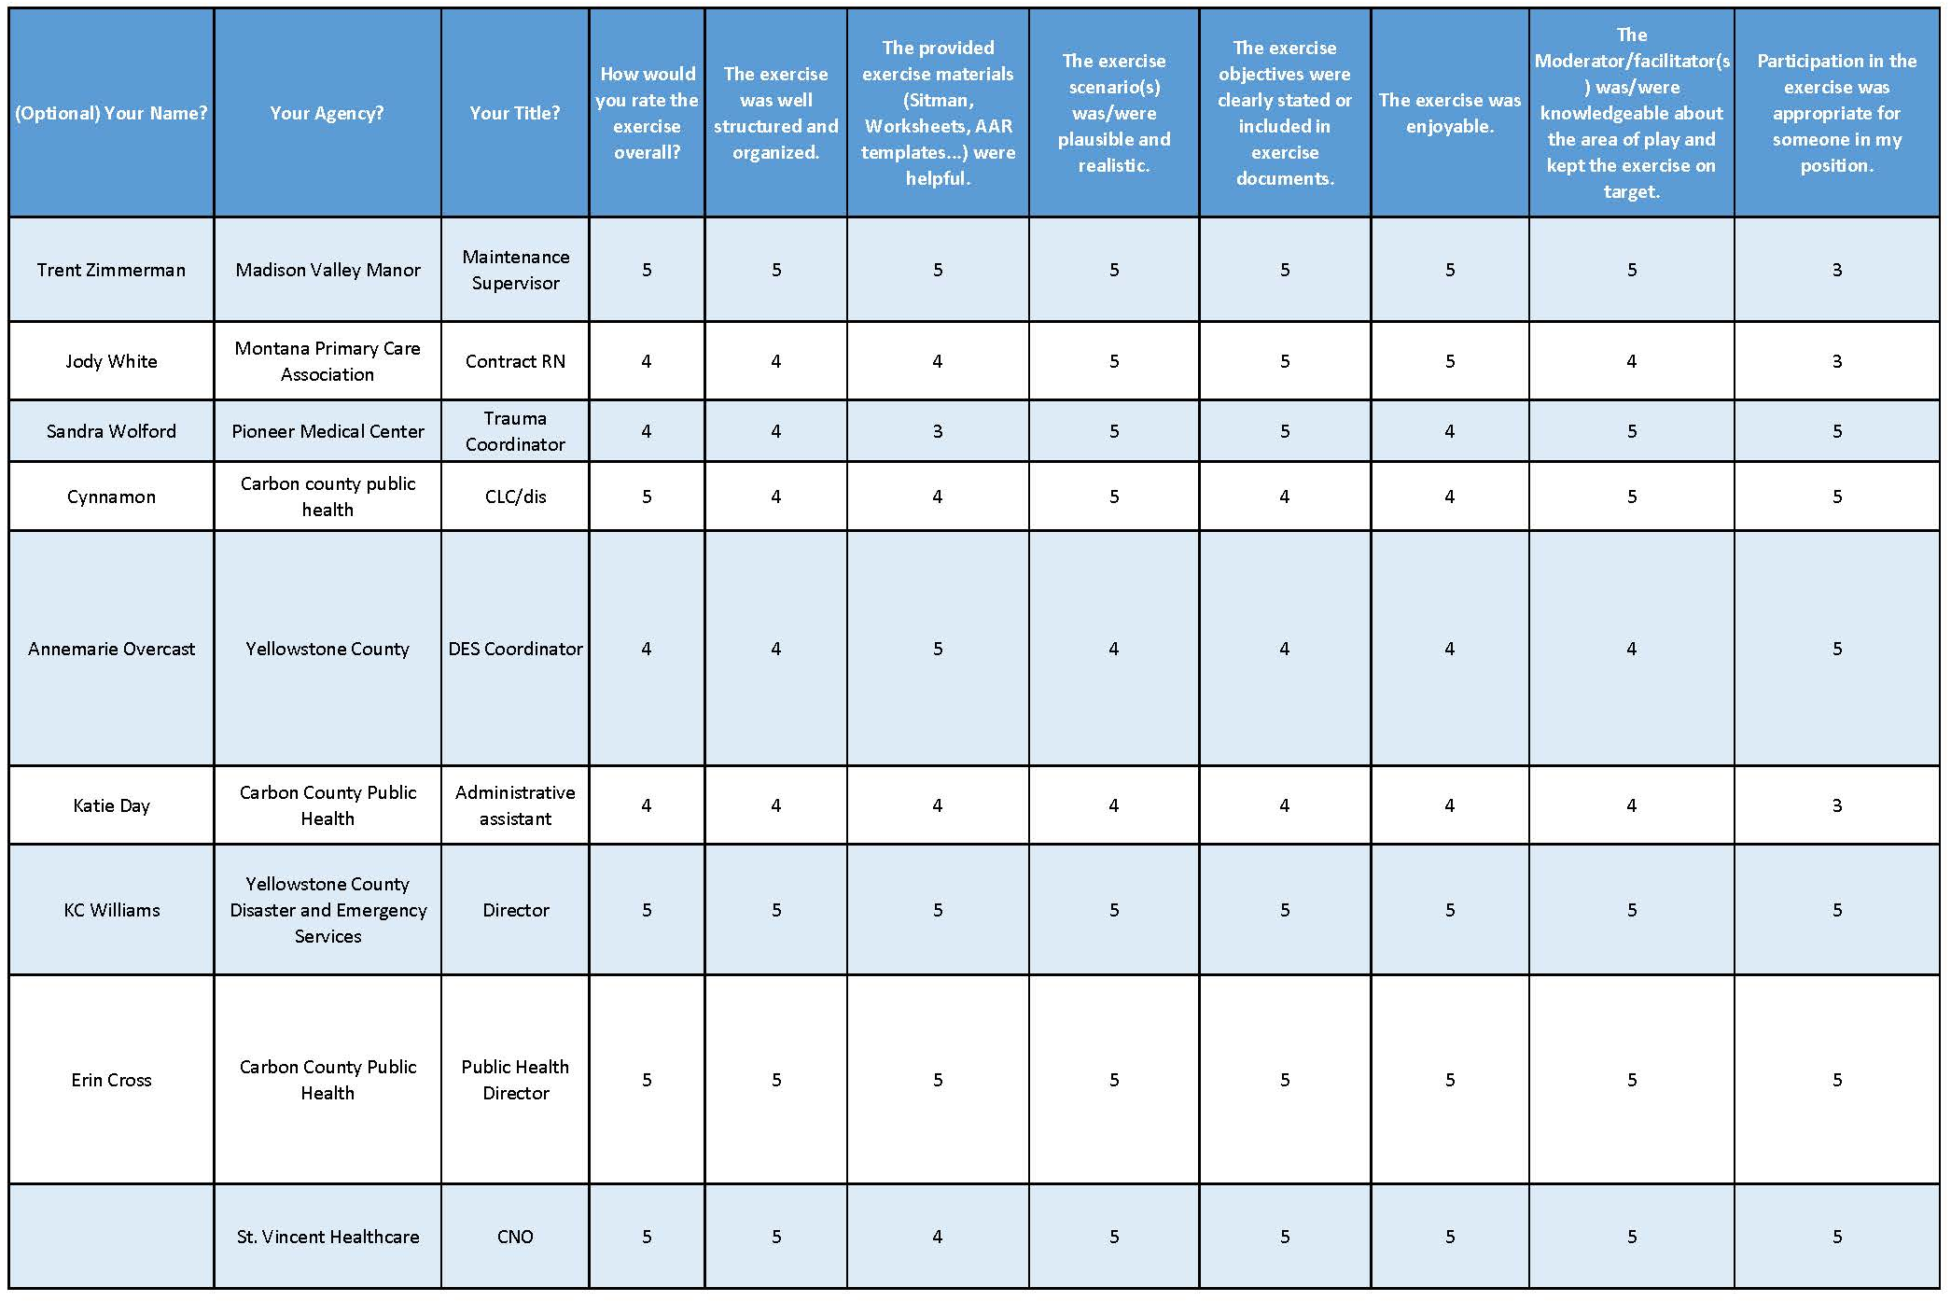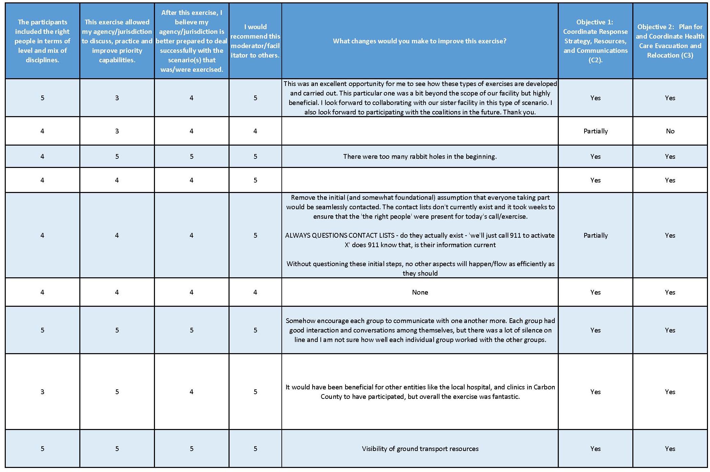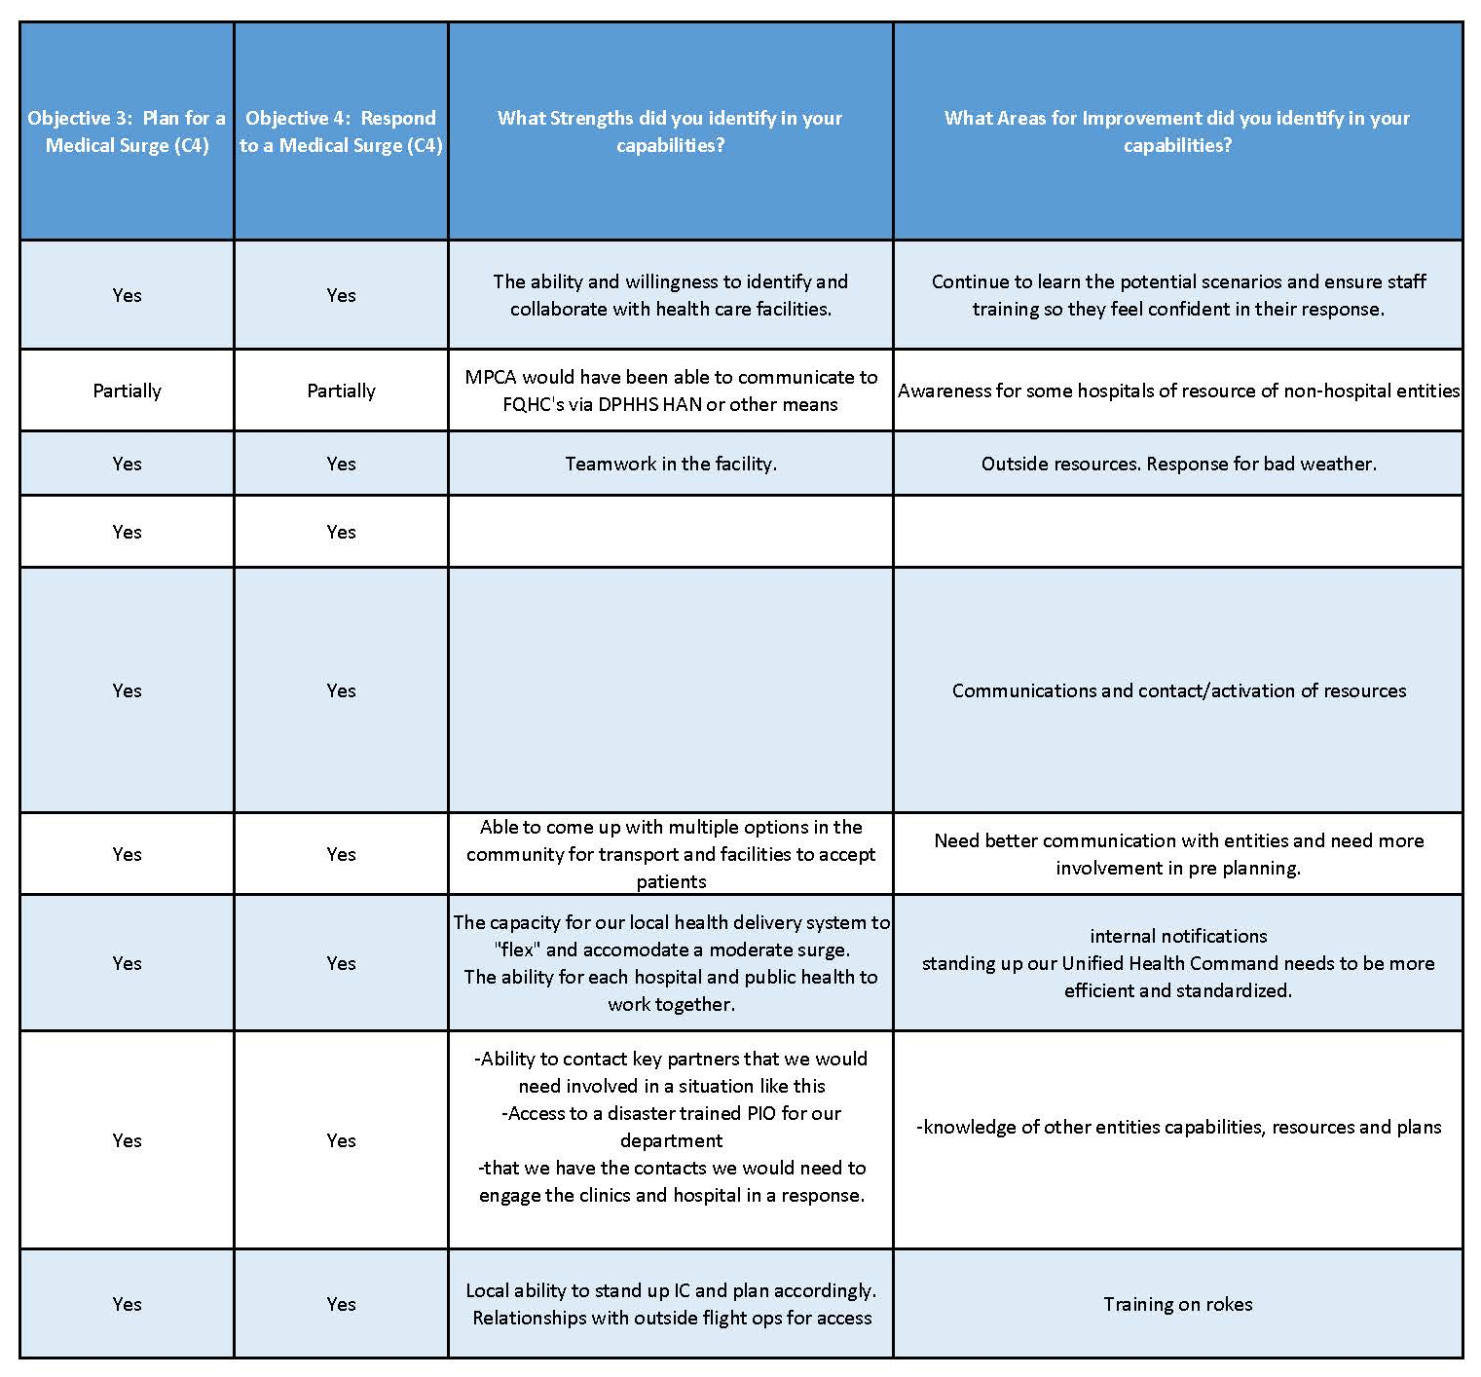

THIS PAGE INTENTIONALLY BLANK

http://dphhs.mt.gov/ | http://www.mtha.org

www.373consulting.com

